**Name: Kamal Agrahari Lab: DevOps**

**ID: VU4F2223028 TE | IT | A**

**Experiment:08**

**Aim:** Demonstration to Create Maven Pipeline.

**Theory:**

Step1: Create a new item/job with itme type as pipeline.

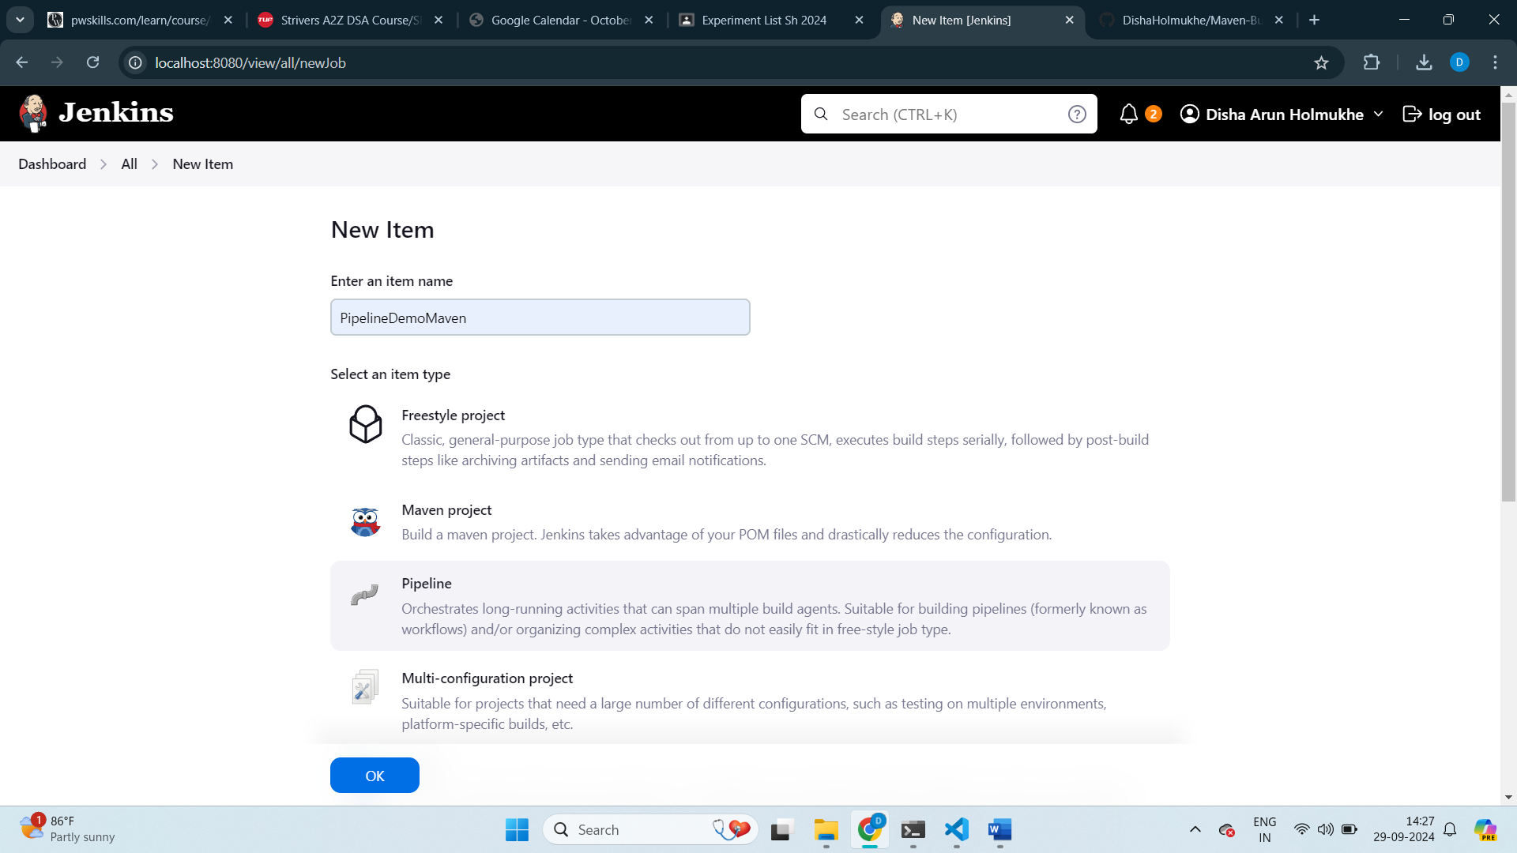

Step2: In General set github project with the github url to the maven project.

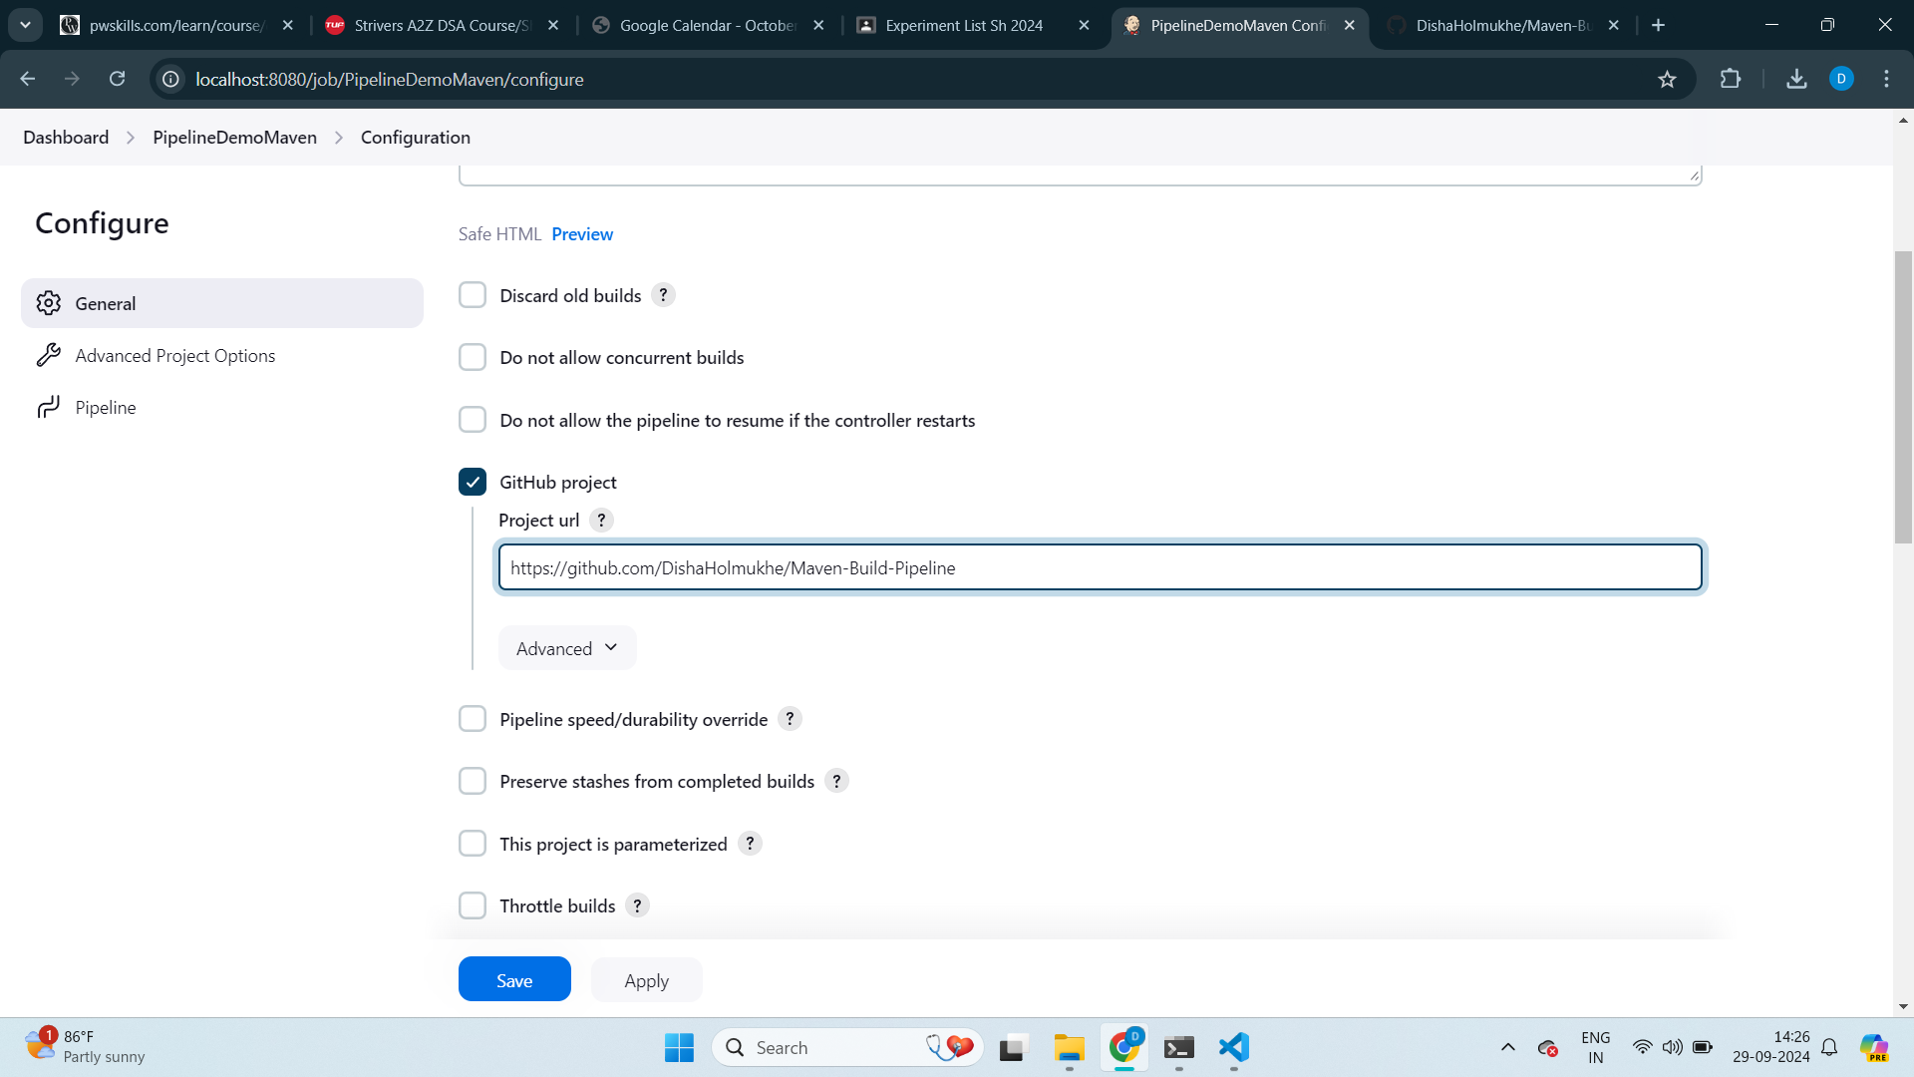

Step3: In Pipeline choose Pipeline Script

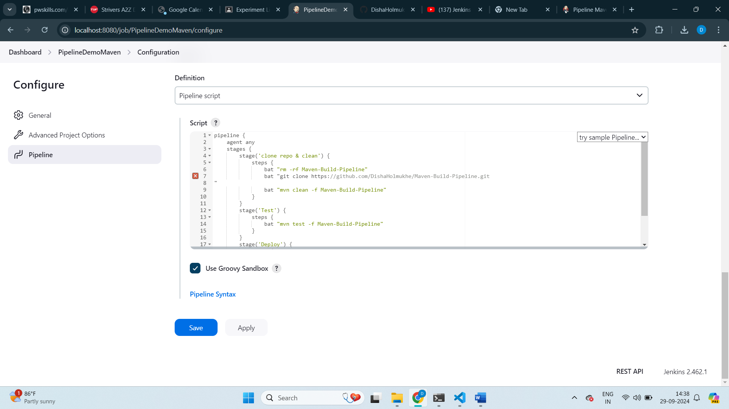

Step4: Click save and Build now.

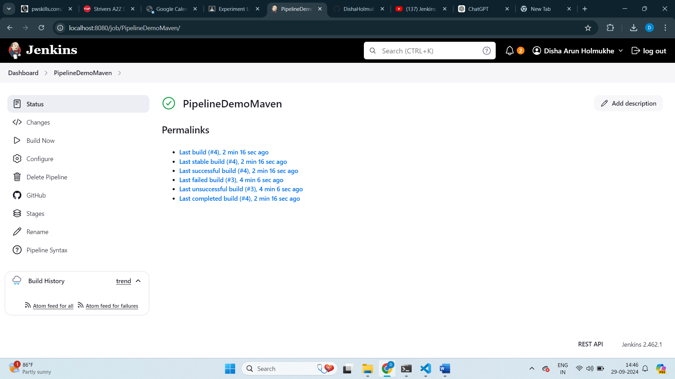

Step5: Click on stages to see the execution of pipeline in each stage.

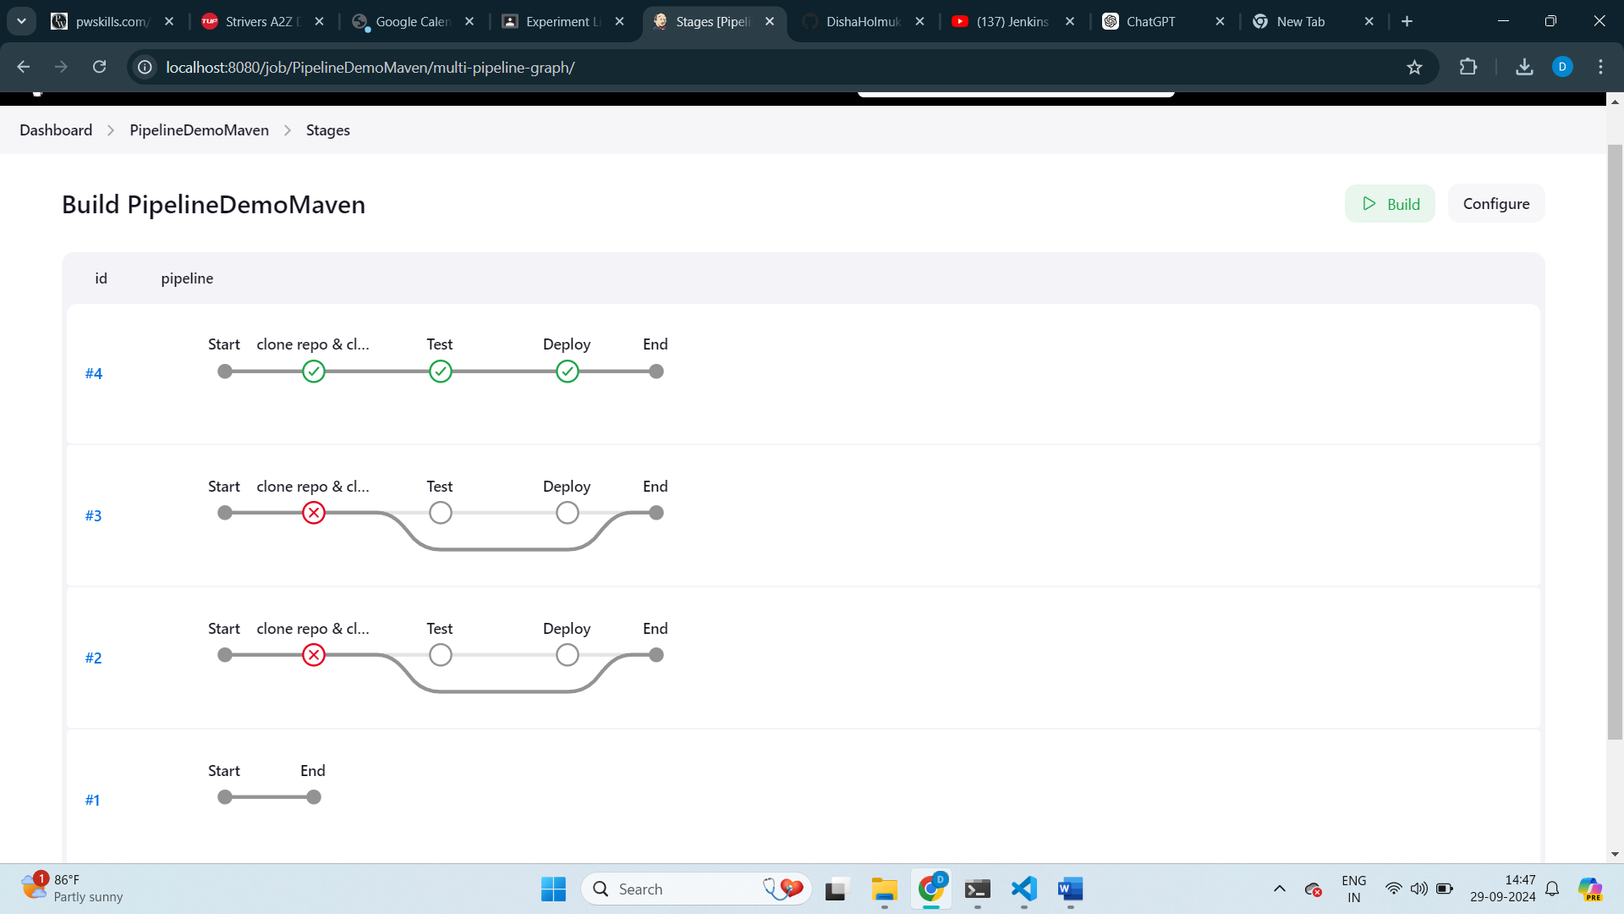

Step6: The console output displays “Finished:SUCCESS”. The pipeline is executed successfully.

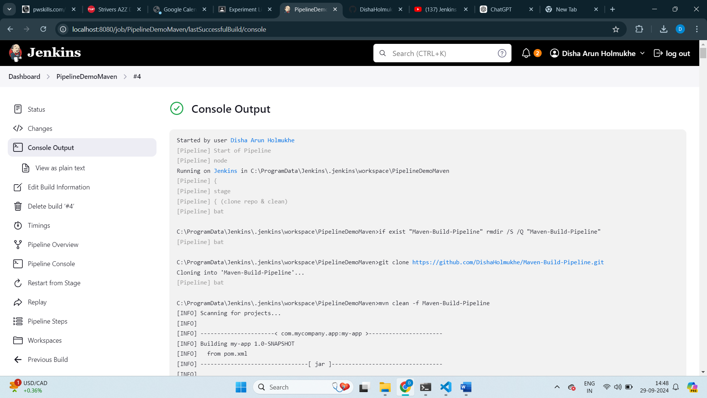

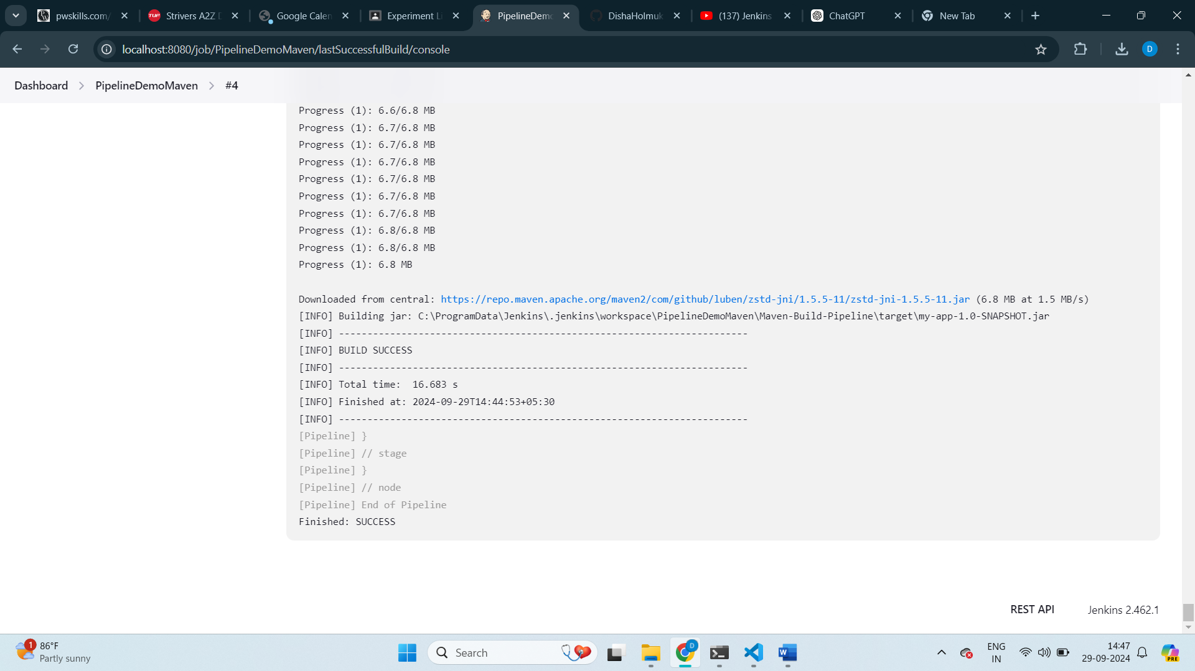

**Building Maven pipeline using Pipeline script SCM**

Step1: Create a new item/job with item type as pipeline.

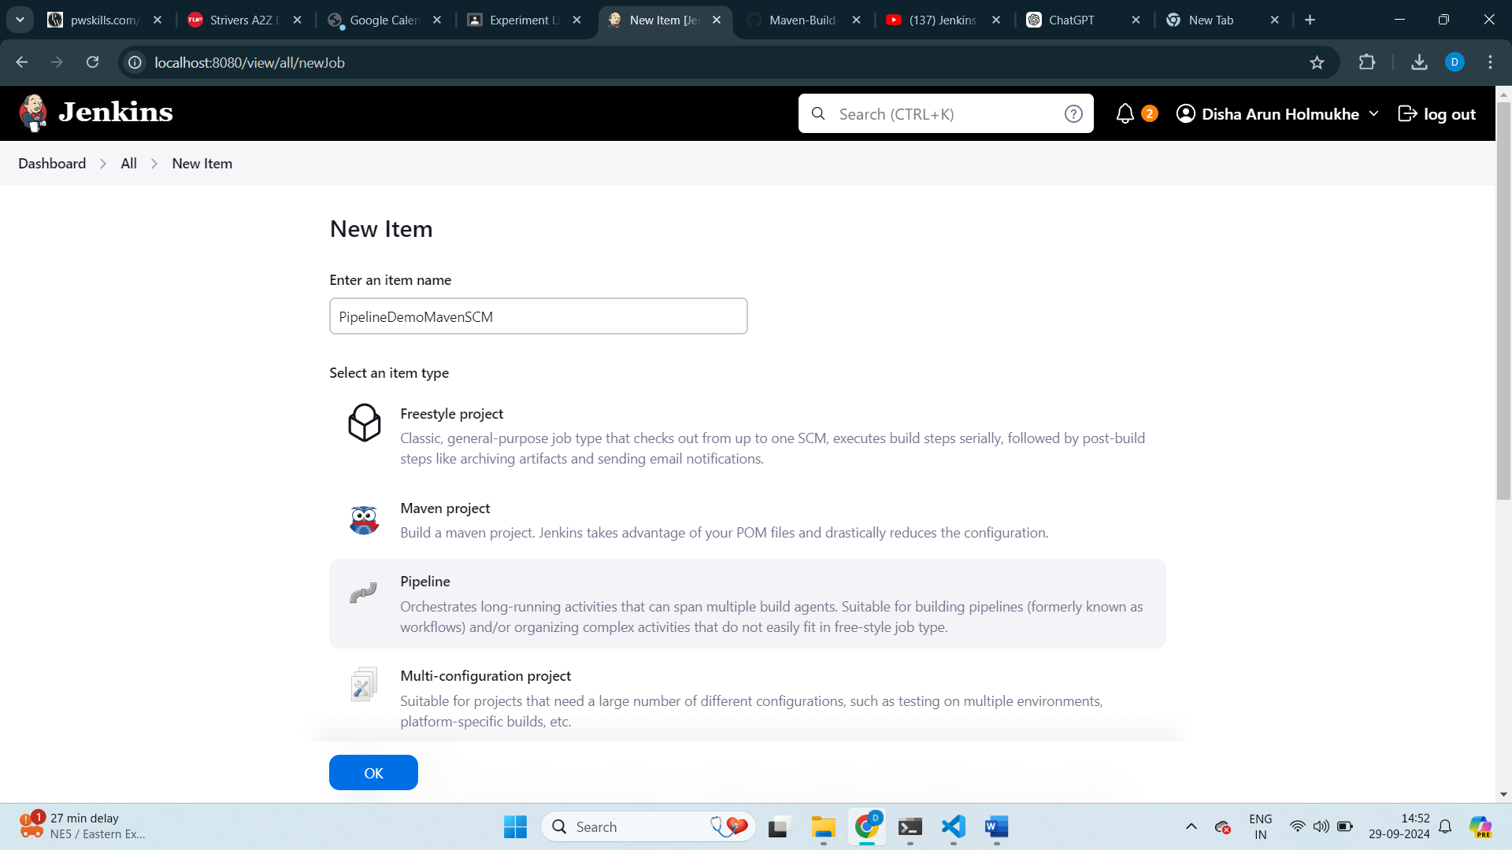

Step2: In General set github project with the github url to the maven project.



Step3: In pipeline select Pipeline Script from SCM.

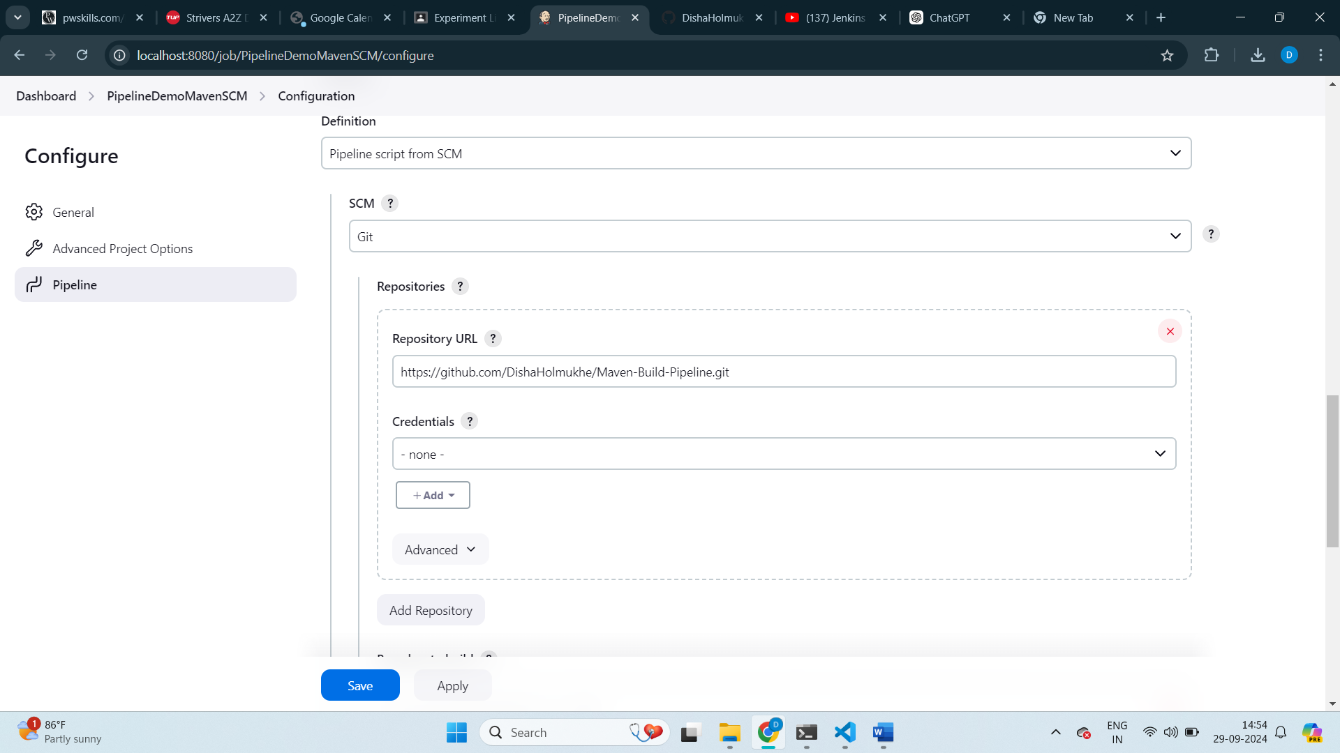

Step4: Set branch to main and Script path to the Jenkins file of your github repository.

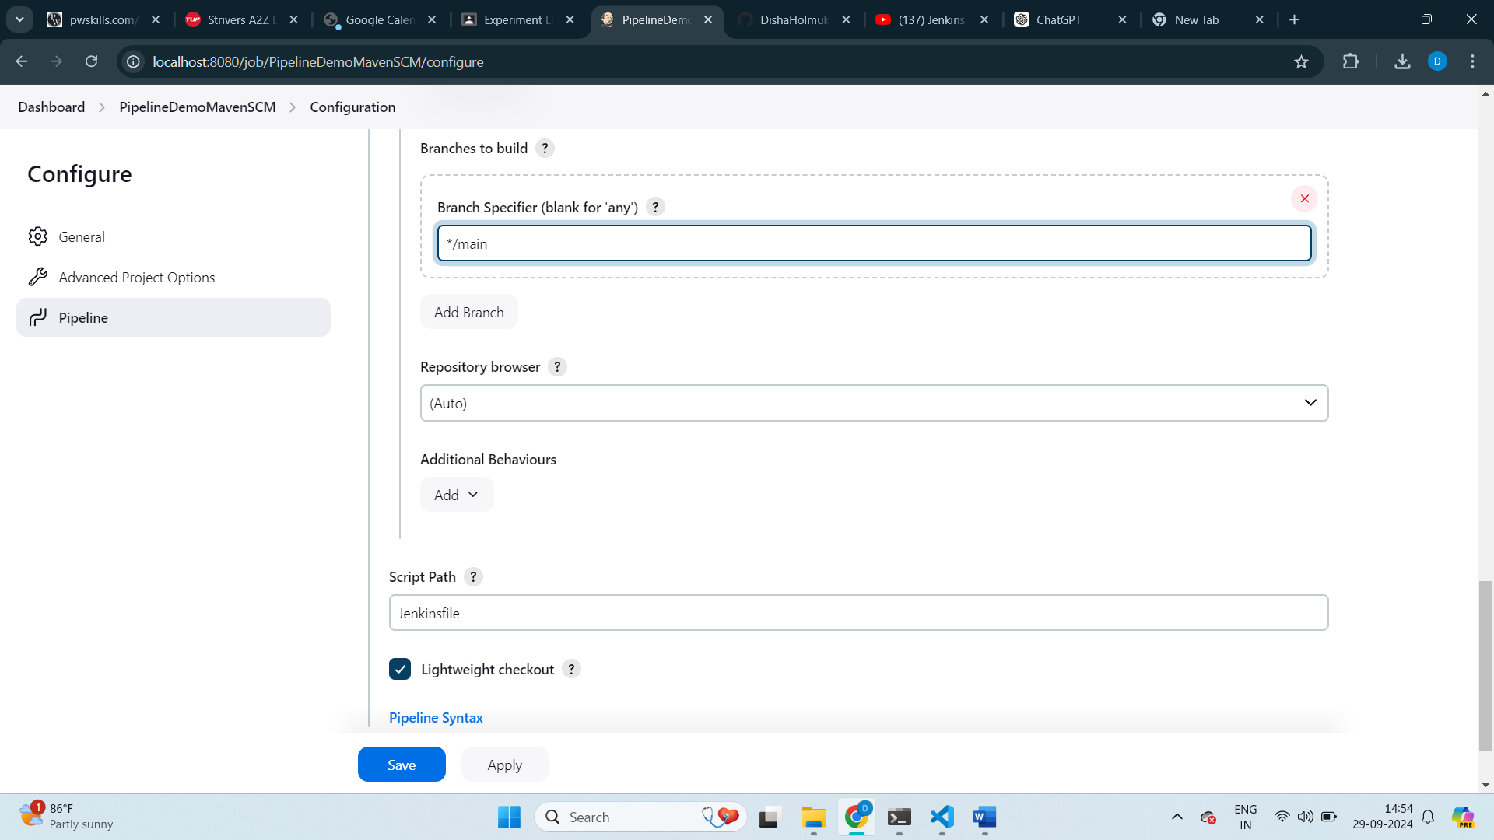

Step5: Click save and build now.

Step6: The Jenkinsfile should be in the Root of your repository.

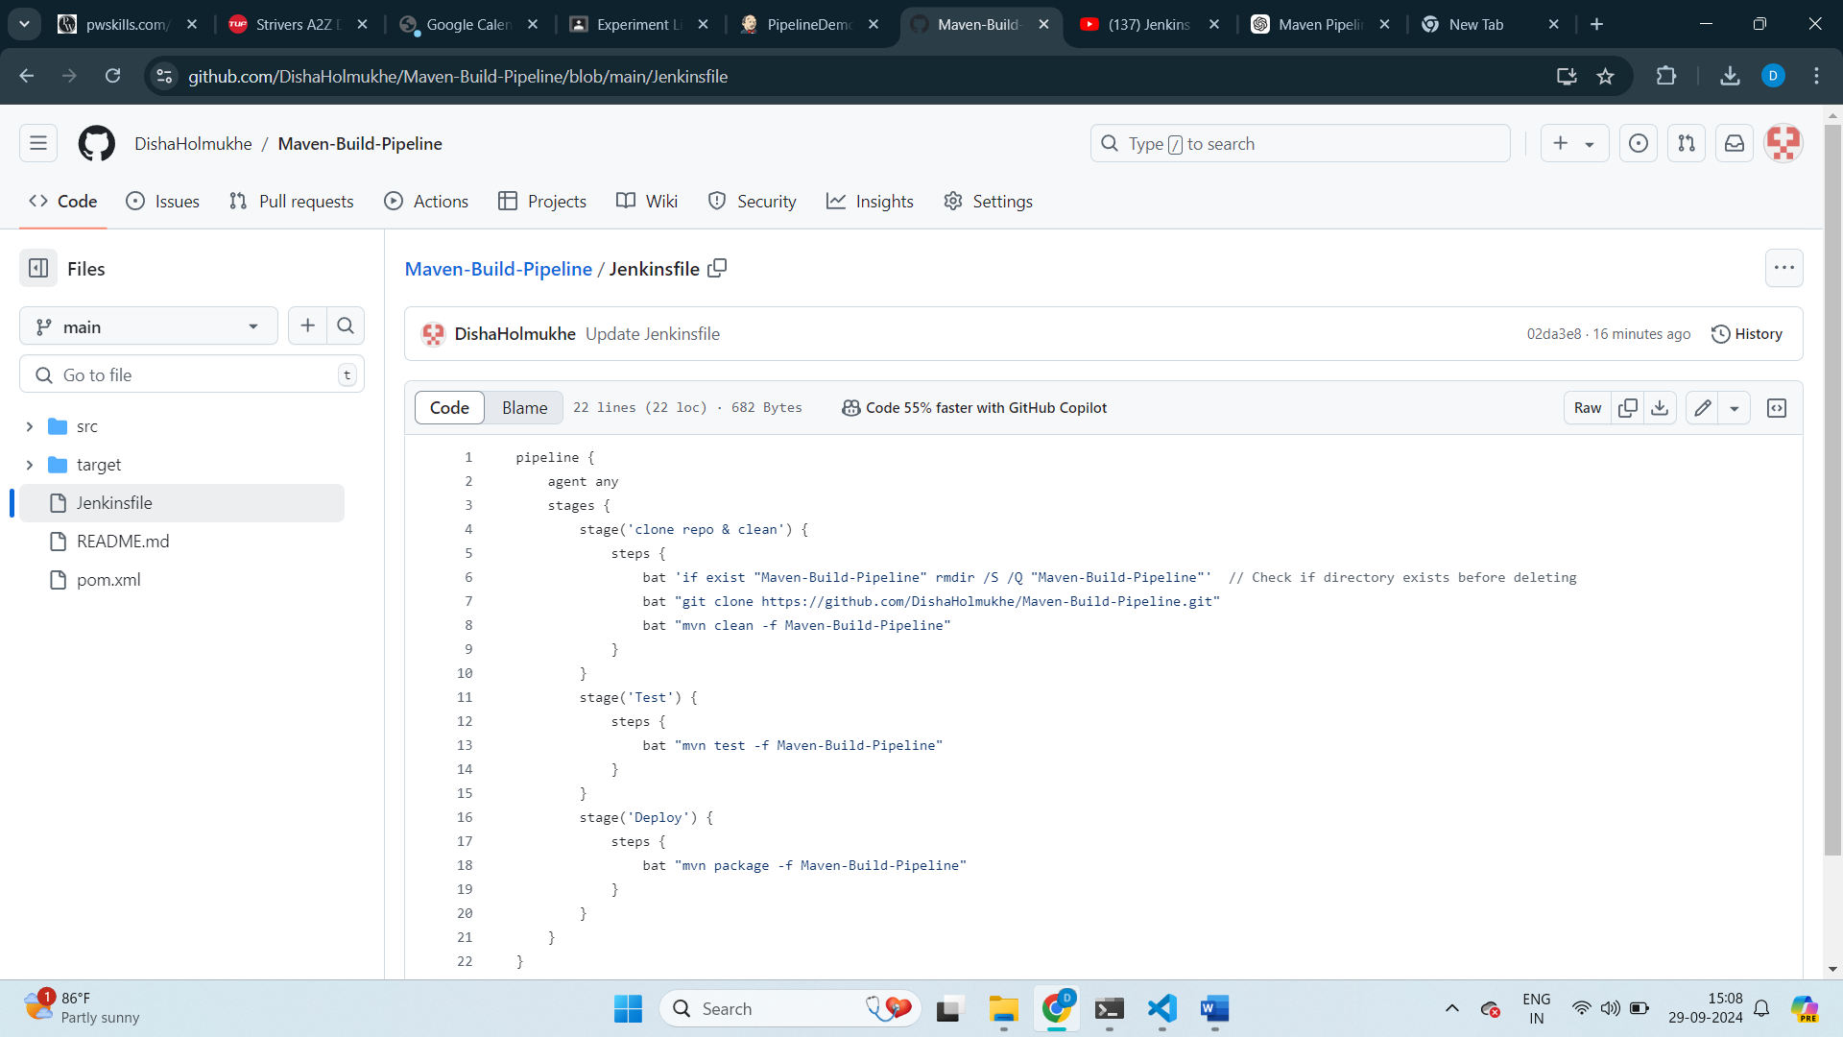

Step5: Click on stages to see the execution of pipeline in each stage.

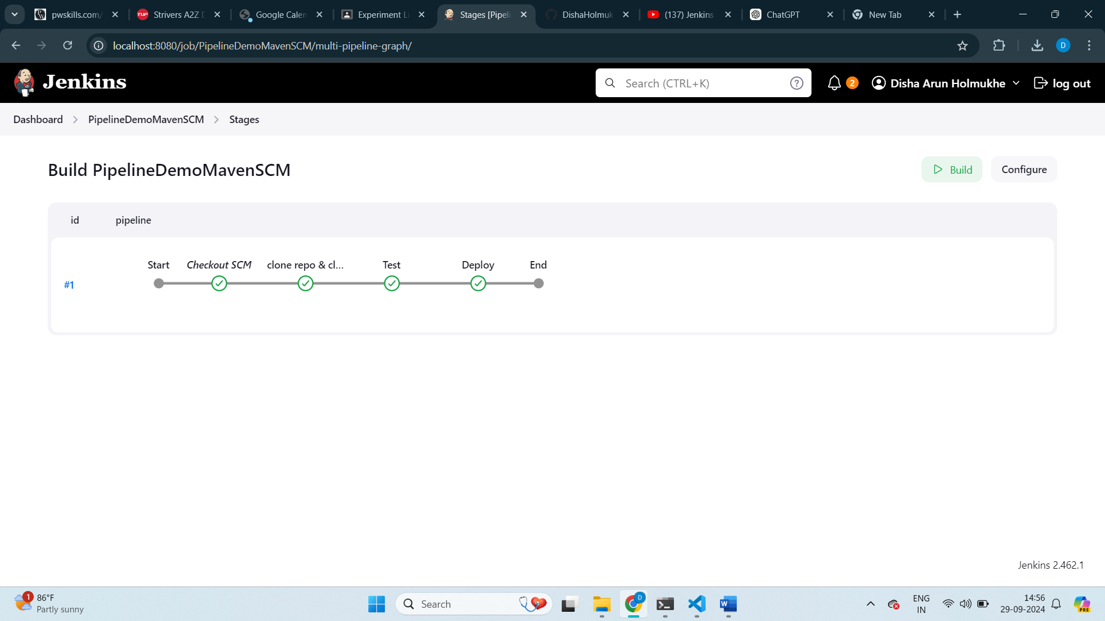

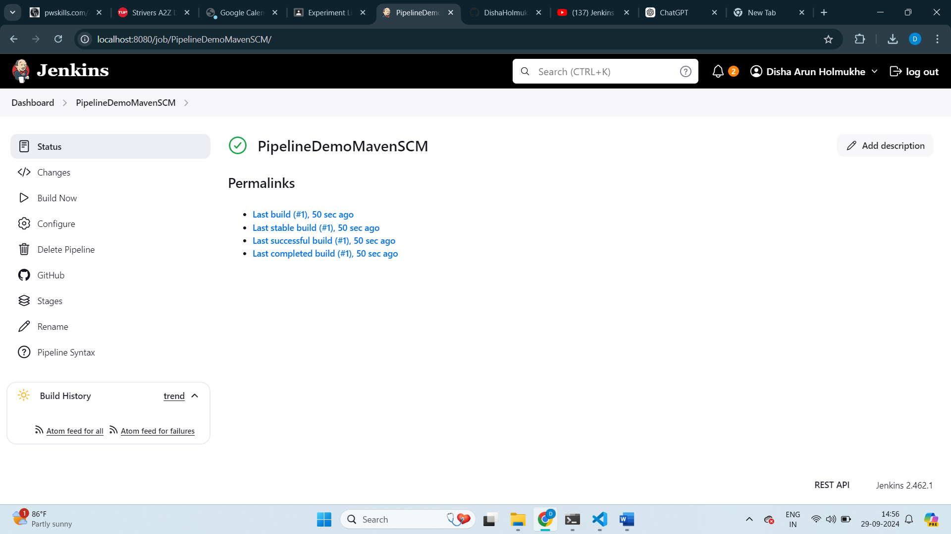

Step6: The console output displays “Finished : SUCCESS”. The pipeline is executed successfully.

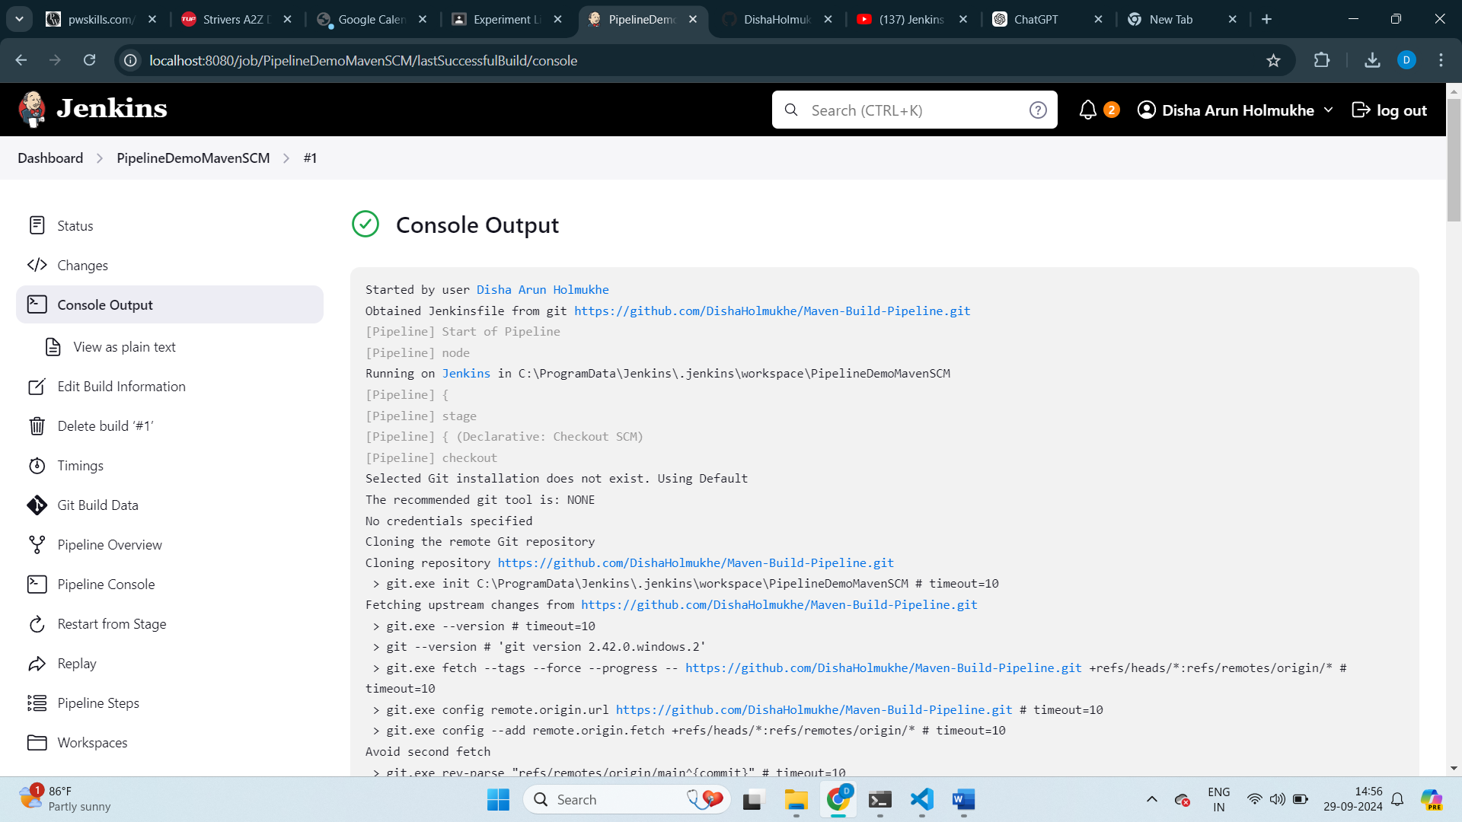

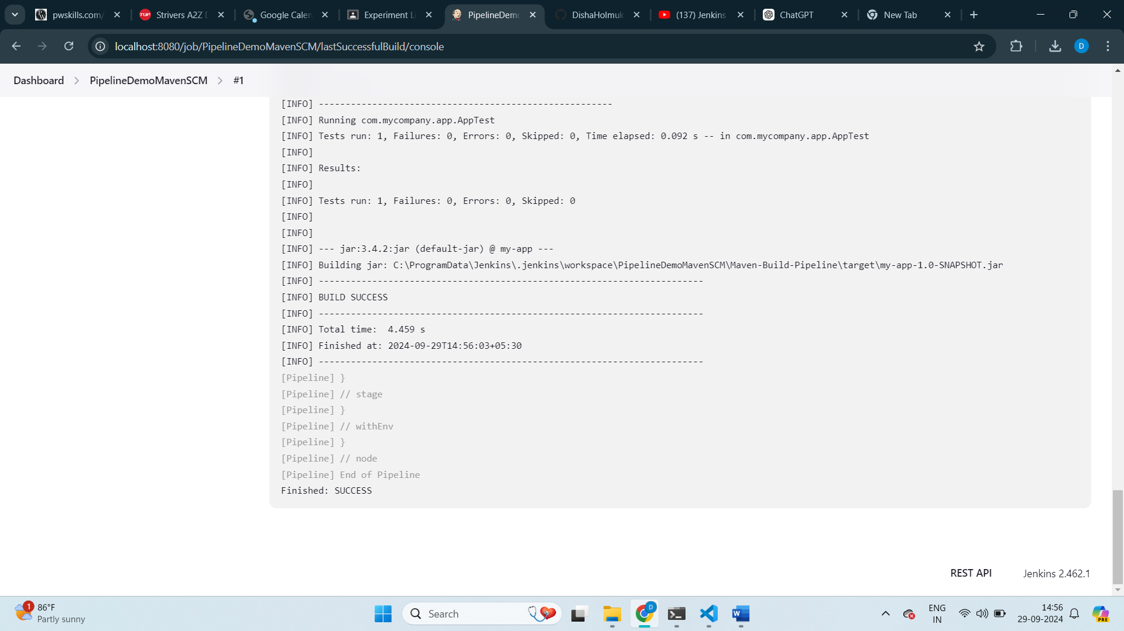

**Conclusion:** Successfully completed the demonstration to Create Maven Pipeline.